Washington School for the Deaf Physical Education and Health

Instructor: Caleb Hinton
Location: Hunter Gym
Office: PE Office (#171)
Class: Middle School PE and Health

Schedule:
- 5th Period, PE/Health
- Mondays-Thursdays, 12:59-1:58pm
- Friday B only (9:30-10:29am)

Course Description:

General PE includes a wide variety of sporting games, and the rules and skills to play them. Throughout this course, we will cover the history, rules, and skills of each team sport that will enhance students’ understanding of sports. Students will gain a better understanding of how to perform specific skills of each team sport and will apply these skills to scrimmages and games. Finally, this course will enable students to work as a team and learn from each other and rely on each other for success.

Health education provides students with knowledge, attitudes, and skills to make health-promoting decisions. The course addresses the physical, mental, emotional, and social aspects of health. Good health is not a one-time decision but a series of decisions continuing throughout our lives. Students will develop comprehension and understanding in the areas of Personal Wellness, Mental and Emotional Health, Body Systems and Disease, and Nutrition and Fitness.

Objective:

PE & Health
- Students will be able to develop skill, interest, and the appreciation for the need of lifelong learning, activity, and recreation.
- Students will receive feedback and share ideas that will enhance their lives and well-being.
- Students will be able to strive for achievable and personal goals.
Health
- Students will have experiences and skills that give release from emotional strain and tension.
- Students will be able to counteract major risk factors of heart diseases.
- Students will be able to improve self-esteem and self-control.
- Students will be able to develop good social behavior with others.
- Students will be able to apply balanced nutrition and healthy eating along with personal wellness to their daily lives.

PE
- Students will learn plyometric/agility activity that will enable each student to monitor desired gains.
- Students will be able to improve muscular strength, flexibility, and endurance.
- Students will be able to experience conditioning activities, as well as individual and team activities.
- Students will be able to identify the fundamental guidelines and techniques of plyometric, and conditioning drills.
Class Expectations:
- Be respectful to everyone, no bullying or verbal abuse allowed.
- Use school equipment appropriately and always follow safety procedures.
- PLEASE to bring proper gym clothes and shoes
- Do NOT wear jewelry while participating in PE classes (watches, necklaces, rings, bracelets, earrings, body piercing, bands, etc.).
- Raise your hand if you have a question or comment, do not talk over others, and pay attention when asked to do so.
- Always be on task and follow instructions.
- All students are expected to try their best, participate, and have fun during class.
PE Uniforms (REQUIREMENTS):
*Your child must wear a WSD PE shirt and WSD PE short to the PE class. If your child doesn’t bring/wear WSD PE clothes/proper shoes, and this will impact on her/his grade. Please bring WSD PE clothes/proper shoes to the PE class every day except Fridays. I have WSD PE shirts and shorts to provide to your child in first two weeks of the school. Here (below) are two pictures of WSD PE shirts and WSD PE shorts to provide your child and keep it for school year.

*WSD PE shirt
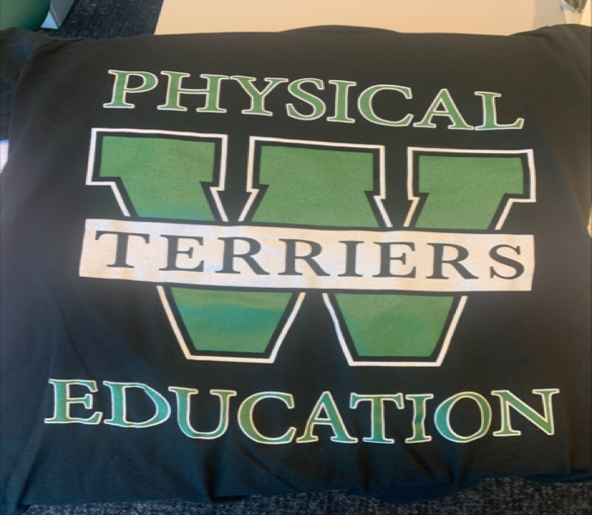

*WSD PE short

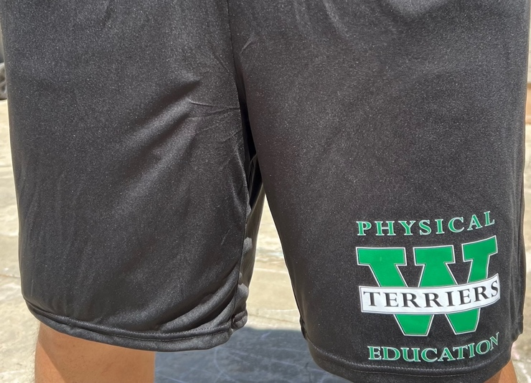

Proper gym shoes/sneakers:
* Only athletic sneakers with non-marking soles are permitted for weightlifting. Boots, loafers, flats, dress shoes, sandals, flip flops, slippers, crocs, Converse and heels are not safe nor appropriate footwear for PE activities. Shoes must also be secured on the student's feet

Course Content:

Basketball Track & Field Fitness testing Tchoukball
Flag Football Volleyball Floor Hockey Soccer-Golf
Ultimate Frisbee Softball Lacrosse
Speedball Tennis Badminton
Pickle ball Team Handball Soccer
Grade System:
Participation: (60%)
10 points per day, 40 points for full week (four days) and Friday on B schedule
- Participation= 5 points
- WSD PE uniforms for PE class= 2 points
- Proper shoes (Tennis shoes) = 2 points
- On time= 1 point
Homework Grade: (10%)
Tests/Quizzes/Projects: (30%)
Letter grade | Percent ranges | Scale value | General rubric
A | 93-100 | 4.0 | Exceeds expectations
A- | 90-92.9 | 3.7
B+ | 87-89.9 | 3.3
B | 83-86.9 | 3.0 | Meets expectations
B- | 80-82.9 | 2.7
C+ | 77-79.9 | 2.3
C | 73-76.9 | 2.0 | Approaching expectations
C- | 70-72.9 | 1.7
D+ | 67-69.9 | 1.3
D | 60-66.9 | 1.0 | Does not meet expectations
F | <60 | 0 | No evidence

Artificial Intelligence (AI) Guidelines
- Teachers may use these AI levels, shown below, to communicate their expectations for students' use of AI to complete various creative assignments in and out of the classroom.
- If a teacher has yet to specifically indicate whether generative AI is recommended or permitted for an assignment, students should ask before using generative AI.
- When generative AI is recommended or permitted, students should rely on their classroom teacher for 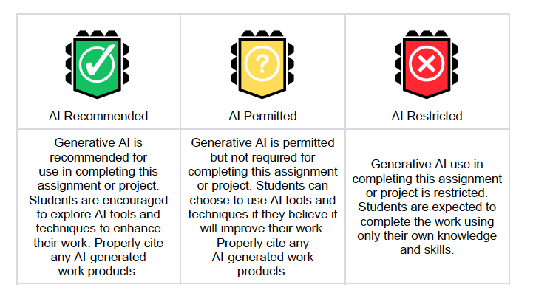further guidance on the extent to which they may use it in the context of the specific assignment.
This code of conduct is intended to guide students in using Artificial Intelligence responsibly and ethically in their academic work and projects. Teachers may use the AI Levels to classify assignments or projects as needed and should provide students with clear expectations for when AI is appropriate, permitted, or restricted. AI must be consistent with the district’s expectations regarding academic integrity. Misuse of generative AI may be considered cheating or plagiarism.

Please RESPECT each other as a special and unique person. ATTITUDE IS EVERYTHING!!!!

For Extra Help:
See Mr. Hinton after class to arrange for a session or email at caleb.hinton@cdhl.wa.gov

Parents- If you want more frequent communication on how your child is doing in PE, please e-mail me.

VP: (360-718-9555)

