Washington School for the Deaf: Strength/Conditioning
Elective class

Instructor: Caleb Hinton
Location: Hunter Gym (Strength studio/#170)
Office: PE Office (#171)
Class: High School Strength/Conditioning
Schedule:
- 2nd Period, Elective PE class
- Mondays (9:20-10:19am)
- Tuesdays-Thursdays (9:02-10:01am)
- Friday A only (9:30-10:29am)

Course Description:

Strength & Conditioning includes a wide variety of exercises, lifts, agilities, and techniques designed to maximize one’s overall total fitness, strength, and agility. Throughout this course, we will cover weightlifting, fitness and agility topics that will enhance our students understanding of the human body. The student will gain a better understanding of the human musculature and how to target specific area that will enable them to reach personal goals. Finally, this course will enable students to benefit from sport-specific movements and life-long activities allowing each student more functional strength.

Objective:
- To create a physical education program where students are totally accountable for their own actions.
- To give students feedback and share ideas that will enhance their program.
- To provide experience that give release from emotional strain and tension.
- Students will be able to counteract major risk factors of heart diseases.
- Students will be able to improve muscular strength, flexibility, and endurance.
- Students will be able to improve self-esteem and self-control.
- Students will be able to regulate weight control and tone muscles.
- Students will be able to learn how to use the weightlifting equipment in an appropriate and safety manner.
- Students will be able to strive for achievable and personal goals.
- Students will be able to experience that give release from emotional strain and tension.
- Students will be able to develop good social behavior with the other students.
- Students will be able to develop skill, interest, and the appreciation for the need of lifelong learning, activity, and recreation.
- Students will be able to give feedback and share ideas that will enhance their program.
- Students will be able to experience conditioning activity as well as individual works out.

Class Expectations:
- Be respectful to everyone, no bullying or verbal abuse allowed.
- Use school equipment appropriately and always follow safety procedures.
- Do NOT wear jewelry while participating in PE classes (watches, necklaces, rings, bracelets, earrings, body piercing, bands, etc.).
- Raise your hand if you have a question or comment, do not talk over others, and pay attention when asked to do so.
- Always be on task and follow instructions.
- All students are expected to try their best, participate, and have fun during class.

PE Uniforms (REQUIREMENTS):

Your child must wear a WSD PE shirt and WSD PE short to the PE class. If your child doesn’t bring/wear WSD PE clothes/proper shoes, and this will impact on her/his grade. Please bring WSD PE clothes/proper shoes to the PE class every day except Fridays. I have WSD PE shirts and shorts to provide to your child in first two weeks of the school. Here (below) are two pictures of WSD PE shirts and WSD PE shorts to provide your child and keep it for school year.

*WSD PE shirt
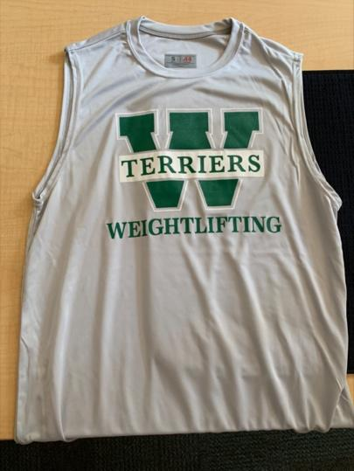
*WSD PE short

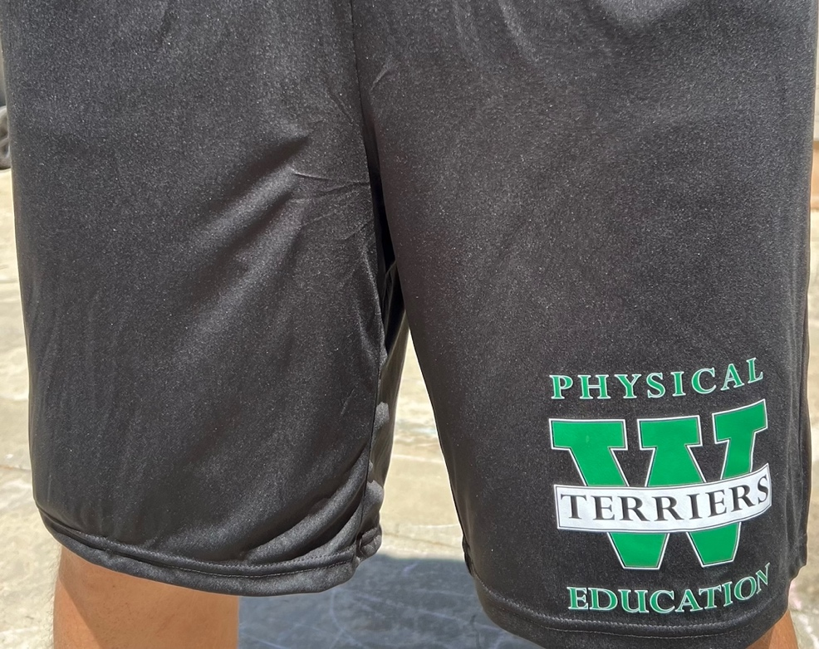

Proper gym shoes/sneakers:
* Only athletic sneakers with non-marking soles are permitted for weightlifting. Boots, loafers, flats, dress shoes, sandals, flip flops, slippers, crocs, Converse and heels are not safe nor appropriate footwear for PE activities. Shoes must also be secured on the student's feet.

Course Content:
Weights Neila Rey Program ABS/Core
Jump activities Squats Running activities
Bench Press Power Clean Incline Press
Hang Clean Mobility Endurance
Flexibility Body Composition

Grade System:

Participation: (90%) 10 points per day, 40 points for full week (four days) and Friday on A schedule.
- Participation= 5 points
- WSD PE uniforms= 2 points
- Proper shoes (Tennis shoes) = 2 points
- On time= 1 point
Quiz: (10%)
- Vocabulary/team teaching

Letter grade | Percent ranges | Scale value | General rubric
A | 93-100 | 4.0 | Exceeds expectations
A- | 90-92.9 | 3.7
B+ | 87-89.9 | 3.3
B | 83-86.9 | 3.0 | Meets expectations
B- | 80-82.9 | 2.7
C+ | 77-79.9 | 2.3
C | 73-76.9 | 2.0 | Approaching expectations
C- | 70-72.9 | 1.7
D+ | 67-69.9 | 1.3
D | 60-66.9 | 1.0 | Does not meet expectations
F | <60 | 0 | No evidence

Artificial Intelligence (AI) Guidelines
- Teachers may use these AI levels, shown below, to communicate their expectations for students' use of AI to complete various creative assignments in and out of the classroom.
- If a teacher has yet to specifically indicate whether generative AI is recommended or permitted for an assignment, students should ask before using generative AI.
- When generative AI is recommended or permitted, students should rely on their classroom teacher for 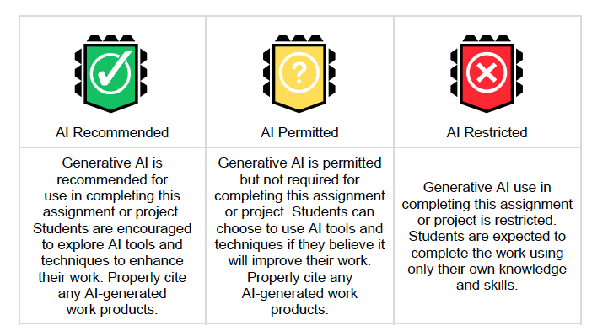further guidance on the extent to which they may use it in the context of the specific assignment.
This code of conduct is intended to guide students in using Artificial Intelligence responsibly and ethically in their academic work and projects. Teachers may use the AI Levels to classify assignments or projects as needed and should provide students with clear expectations for when AI is appropriate, permitted, or restricted. AI must be consistent with the district’s expectations regarding academic integrity. Misuse of generative AI may be considered cheating or plagiarism.

Please RESPECT each other as a special and unique person. ATTITUDE IS EVERYTHING!!!!

For Extra Help: See Mr. Hinton after class to arrange for a session or email at caleb.hinton@cdhl.wa.gov
VP: (360-718-9555)

